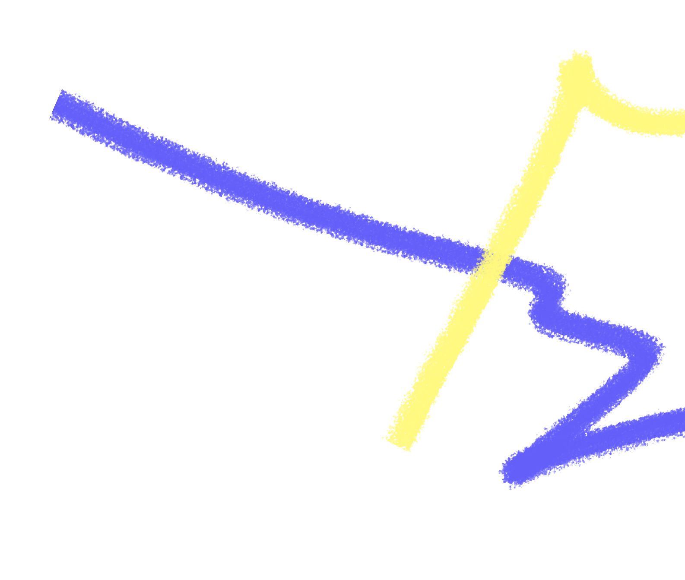
THE ASK

With your support the Australia Government can partner with global institutions, Australian NGOs and our regional neighbours, to address the worst impacts of COVID-19 on the world’s most vulnerable nations and communities.

We have some ideas around how to do this:

Start by protecting those who are most vulnerable to COVID-19 and its impacts, strengthen health systems and protect essential aid programs, and help kick- start economic recovery in the region to secure a bright future for all.

PROTECT THE WORLD’S MOST VULNERABLE

- Contribute our fair share of global humanitarian funding and increase support to crisis areas.
- Prevent a second crisis of communicable disease outbreak – like malaria, ebola and polio – by increasing our investment in global health programs.
- Fund equitable and timely access to a COVID-19 vaccine.

STRENGTHEN HEALTH SYSTEMS

- Provide testing kits, PPE, information campaigns, and medical equipment.
- Ensure health care is made accessible and inclusive to people with disabilities
and other marginalised groups.

- Continue supporting ongoing health programs that are critical and cannot stop – including water project, maternal and child health and sexual and reproductive health.

KICK START ECONOMIC RECOVERY IN OUR REGION

- Lead the safe, staged resumption of regional economic ties including increased support for Pacific workers in Australia.
- Provide low-cost loans for the Pacific to finance vital health infrastructure and kick-start economic recovery.
- Secure an immediate halt on debt interest payments for developing countries.

